# S.0. GENERAL INFORMATION

All data is available at: https://github.com/joaohuf/2025_CBDB_Future_Climate_Scenarios

# S.1. PRECIPITATION DATA

The precipitation data was obtained from two different types of gauging stations, available at the Brazil National Water Agency (ANA – Agência Nacional de Águas) website: <https://www.snirh.gov.br/hidroweb/serieshistoricas>.

Data from 1945 to 2015 were used from conventional gauging stations, while from 2015 to 2024 automatic telemetric stations were selected (see Figure 1 and Figure 2). All data correspond to daily accumulated precipitation.

Due to the large volume of data, a detailed analysis of each station was not feasible. However, to minimize measurement errors, three automatic filters were applied. Measurements were discarded if they met either of the following criteria:

* Gauging station with less than 10 years of data.
* Values larger than 600 mm (unfeasible value for the catchments in the south of Brazil).
* Values larger than the outlier indicated by the Grubbs-Beck test (Naghettini and Pinto, 2007):
  + The outlier limit was defined based on the annual maximum precipitation data and was estimated for every single station.

After further analysis, only the first criterion was applied, as only stations with less than 10 years of data contained values that would be excluded by the next steps.

**Figure 1.** **Gauge Stations on Antas River watershed** 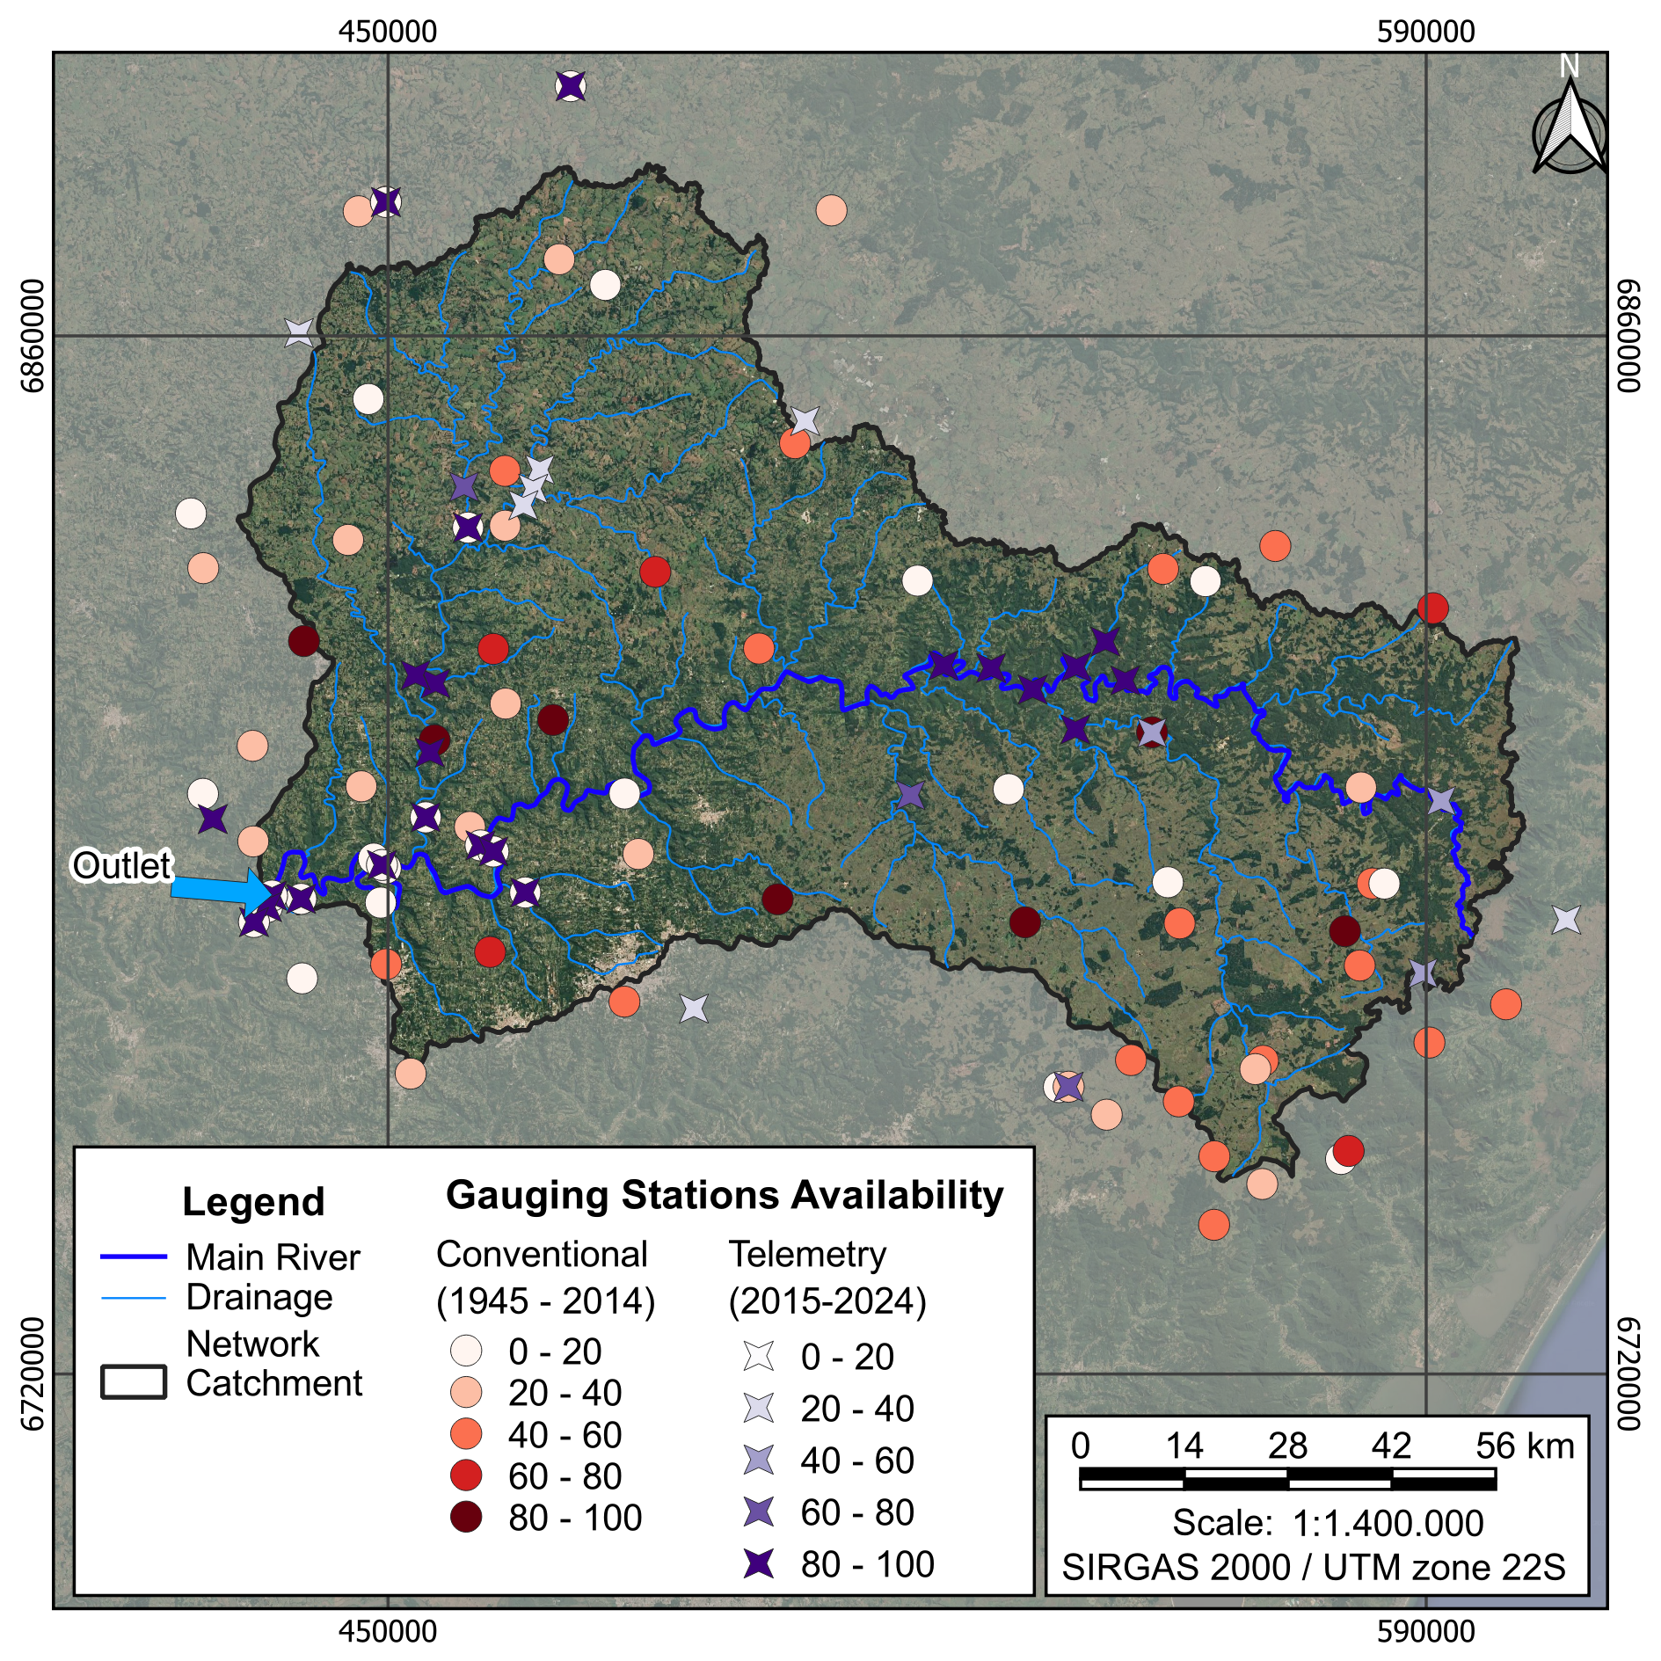

**Figure 1. Number of Gauge Stations Available and Source Used** 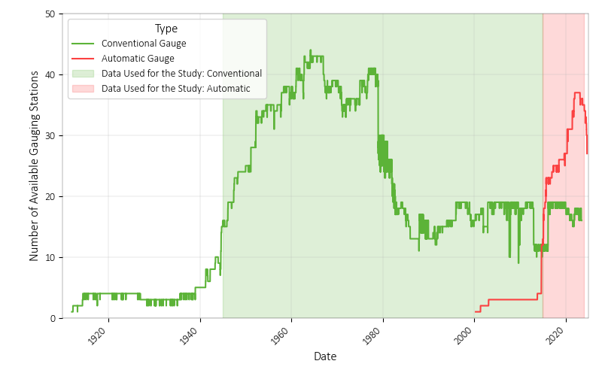

**Figure 3. Daily Precipitation Time Series.** 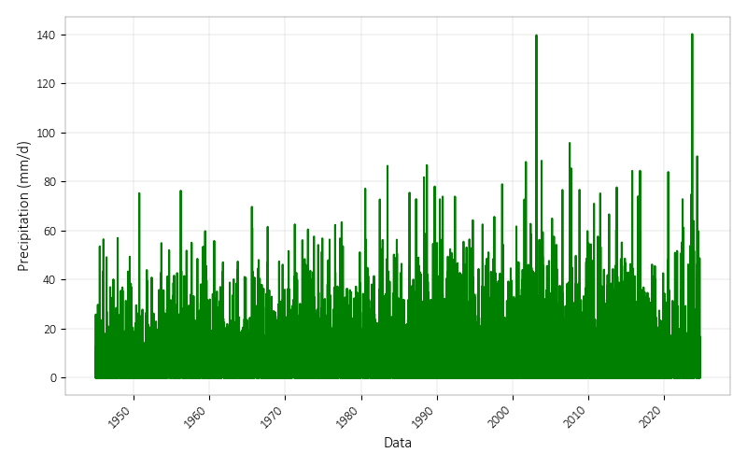

After data pre-processing and the application of the weighted average using the Thiessen method (Figure 3), annual precipitation was calculated for durations ranging from 1 to 5 days (Table 1). Additionally, Figures 4 and 5 present the monthly and annual precipitation data, showing both accumulated values and 1-day maximums.

**Figure 4. Monthly Precipitation Time Series.**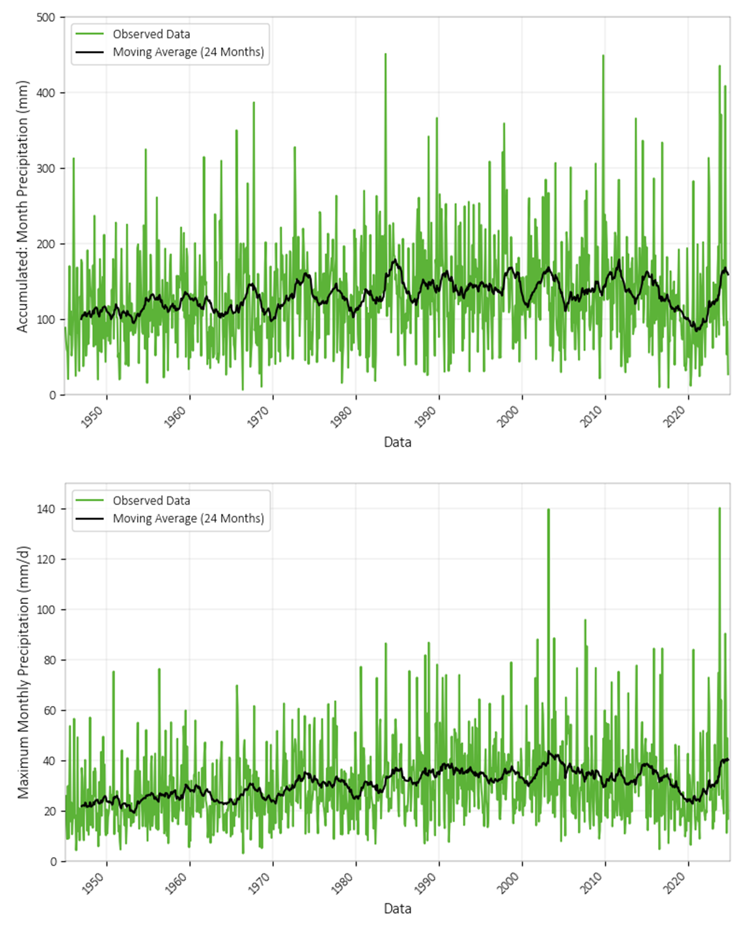

**Figure 5. Annual Precipitation Time Series.**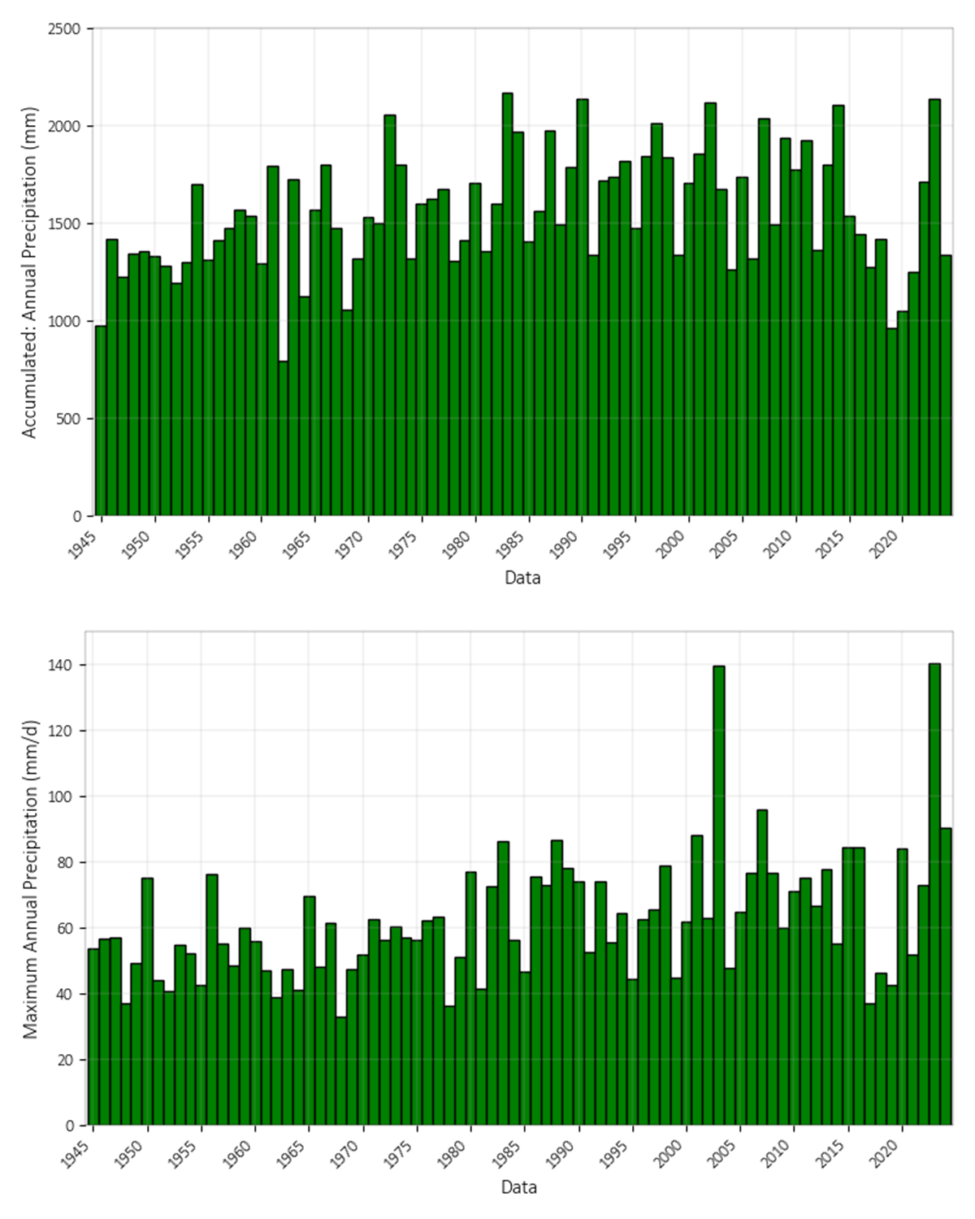

**Table 1. Maximum Annual Precipitation Time Series.**

| **Year** | **Accumulated Precipitation (mm)** | | | | |
| --- | --- | --- | --- | --- | --- |
| **1 Day** | **2 Days** | **3 Days** | **4 Days** | **5 Days** |
| 1945 | 53.6 | 82.4 | 98.8 | 111.5 | 127.1 |
| 1946 | 56.5 | 109.0 | 131.9 | 135.4 | 135.7 |
| 1947 | 57.0 | 69.7 | 78.3 | 83.6 | 92.3 |
| 1948 | 36.8 | 56.1 | 78.9 | 97.3 | 109.2 |
| 1949 | 49.4 | 80.8 | 109.4 | 112.2 | 112.4 |
| 1950 | 75.2 | 107.3 | 111.2 | 115.3 | 125.2 |
| 1951 | 43.9 | 74.7 | 79.9 | 84.5 | 94.0 |
| 1952 | 40.8 | 54.3 | 63.9 | 67.5 | 94.1 |
| 1953 | 54.9 | 65.6 | 68.8 | 71.7 | 77.2 |
| 1954 | 52.0 | 98.0 | 102.4 | 109.6 | 150.6 |
| 1955 | 42.7 | 61.0 | 73.7 | 85.3 | 89.4 |
| 1956 | 76.3 | 119.9 | 154.4 | 163.2 | 172.1 |
| 1957 | 55.1 | 80.8 | 85.8 | 90.4 | 112.0 |
| 1958 | 48.5 | 78.3 | 93.7 | 97.1 | 98.7 |
| 1959 | 59.8 | 104.6 | 111.6 | 114.6 | 115.8 |
| 1960 | 55.8 | 75.2 | 84.3 | 104.3 | 108.4 |
| 1961 | 47.1 | 67.7 | 84.9 | 98.0 | 113.8 |
| 1962 | 38.8 | 45.4 | 49.4 | 53.5 | 64.2 |
| 1963 | 47.4 | 75.4 | 102.0 | 111.2 | 126.0 |
| 1964 | 41.1 | 54.0 | 61.5 | 67.9 | 71.8 |
| 1965 | 69.7 | 121.7 | 162.0 | 196.2 | 220.0 |
| 1966 | 48.0 | 74.9 | 82.4 | 93.6 | 99.3 |
| 1967 | 61.5 | 101.2 | 158.5 | 166.4 | 168.1 |
| 1968 | 33.0 | 53.1 | 63.9 | 80.1 | 89.7 |
| 1969 | 47.4 | 62.2 | 70.9 | 77.3 | 90.4 |
| 1970 | 51.6 | 66.8 | 75.2 | 89.8 | 94.4 |
| 1971 | 62.5 | 72.5 | 80.3 | 85.3 | 103.5 |
| 1972 | 56.1 | 80.9 | 112.4 | 128.1 | 132.9 |
| 1973 | 60.5 | 77.4 | 108.8 | 139.4 | 144.8 |
| 1974 | 56.8 | 77.9 | 79.9 | 82.2 | 83.5 |
| 1975 | 56.4 | 62.3 | 72.3 | 87.6 | 105.1 |
| 1976 | 62.3 | 74.8 | 80.0 | 82.2 | 106.1 |
| 1977 | 63.4 | 98.1 | 124.1 | 127.7 | 137.6 |
| 1978 | 36.4 | 69.7 | 91.8 | 98.3 | 120.4 |
| 1979 | 51.2 | 54.6 | 65.0 | 68.4 | 74.9 |
| 1980 | 77.1 | 126.0 | 138.3 | 152.4 | 175.2 |
| 1981 | 41.4 | 60.4 | 75.3 | 99.0 | 119.9 |
| 1982 | 72.7 | 122.5 | 141.2 | 155.7 | 156.1 |
| 1983 | 86.4 | 100.5 | 127.5 | 164.5 | 193.0 |
| 1984 | 56.3 | 86.6 | 100.0 | 111.4 | 123.5 |
| 1985 | 46.5 | 68.0 | 103.4 | 105.3 | 110.6 |
| 1986 | 75.4 | 89.6 | 94.2 | 98.4 | 102.5 |
| 1987 | 72.8 | 100.0 | 118.5 | 133.6 | 152.1 |
| 1988 | 86.7 | 138.7 | 175.8 | 209.9 | 210.1 |
| 1989 | 78.0 | 136.9 | 140.7 | 142.8 | 148.3 |
| 1990 | 73.9 | 115.4 | 127.8 | 148.9 | 155.6 |
| 1991 | 52.4 | 84.8 | 99.3 | 112.9 | 126.5 |
| 1992 | 73.9 | 111.5 | 122.8 | 125.2 | 125.4 |
| 1993 | 55.4 | 70.1 | 95.1 | 122.1 | 130.7 |
| 1994 | 64.2 | 87.6 | 93.7 | 109.7 | 111.8 |
| 1995 | 44.3 | 55.6 | 74.2 | 92.4 | 100.1 |
| 1996 | 62.5 | 74.3 | 91.6 | 104.2 | 107.5 |
| 1997 | 65.6 | 112.2 | 157.8 | 204.4 | 206.0 |
| 1998 | 78.9 | 81.9 | 84.4 | 105.3 | 110.2 |
| 1999 | 44.6 | 58.6 | 64.0 | 81.8 | 82.4 |
| 2000 | 61.7 | 91.0 | 97.5 | 116.9 | 123.3 |
| 2001 | 88.0 | 131.7 | 139.1 | 154.7 | 162.2 |
| 2002 | 62.7 | 71.2 | 102.7 | 123.1 | 164.1 |
| 2003 | 139.7 | 148.8 | 152.4 | 154.5 | 163.6 |
| 2004 | 47.7 | 58.9 | 81.3 | 94.5 | 101.3 |
| 2005 | 64.9 | 103.0 | 110.6 | 130.5 | 132.5 |
| 2006 | 76.6 | 99.8 | 119.5 | 132.8 | 141.8 |
| 2007 | 95.8 | 123.9 | 157.8 | 185.1 | 201.3 |
| 2008 | 76.6 | 125.0 | 158.5 | 175.5 | 182.7 |
| 2009 | 59.8 | 86.9 | 112.6 | 134.7 | 175.0 |
| 2010 | 71.0 | 93.9 | 108.2 | 123.3 | 123.3 |
| 2011 | 75.2 | 100.2 | 126.4 | 148.4 | 168.6 |
| 2012 | 66.6 | 79.9 | 102.0 | 103.5 | 105.0 |
| 2013 | 77.6 | 115.5 | 150.5 | 174.3 | 196.7 |
| 2014 | 55.2 | 95.6 | 117.5 | 121.5 | 123.8 |
| 2015 | 66.5 | 112.9 | 155.0 | 171.9 | 189.9 |
| 2016 | 73.8 | 131.9 | 179.6 | 210.6 | 219.1 |
| 2017 | 53.4 | 81.4 | 103.6 | 113.4 | 122.4 |
| 2018 | 55.9 | 75.0 | 80.1 | 93.0 | 102.2 |
| 2019 | 69.5 | 84.3 | 87.8 | 99.4 | 114.2 |
| 2020 | 111.8 | 162.1 | 215.0 | 226.2 | 228.7 |
| 2021 | 61.6 | 78.5 | 78.6 | 80.9 | 90.7 |
| 2022 | 69.9 | 103.5 | 149.9 | 170.6 | 178.6 |
| 2023 | 140.2 | 197.5 | 218.1 | 221.7 | 224.1 |
| 2024 | 90.3 | 159.9 | 212.3 | 238.1 | 257.5 |

# S.2. DISCHARGE DATA

The discharge data from the 14 de Julho HPP are available through the Brazilian Reservoir Monitoring System (SAR – *Sistema de Acompanhamento dos Reservatórios*,https://www.ana.gov.br/sar0/MedicaoSin). The annual maximum discharge values are presented in Table 2.

**Table 2. Maximum Annual Discharge Series.**

| **Year** | **Daily**  **Discharge (m3/s)** | **Year** | **Daily**  **Discharge (m3/s)** | **Year** | **Daily**  **Discharge (m3/s)** |
| --- | --- | --- | --- | --- | --- |
| 1940 | 4696 | 1968 | 1921 | 1996 | 2556 |
| 1941 | 7137 | 1969 | 1832 | 1997 | 6845 |
| 1942 | 2078 | 1970 | 2326 | 1998 | 3923 |
| 1943 | 1612 | 1971 | 2981 | 1999 | 2038 |
| 1944 | 2164 | 1972 | 4805 | 2000 | 8640 |
| 1945 | 2366 | 1973 | 4198 | 2001 | 8508 |
| 1946 | 4731 | 1974 | 2269 | 2002 | 4879 |
| 1947 | 1998 | 1975 | 2897 | 2003 | 4445 |
| 1948 | 2996 | 1976 | 4887 | 2004 | 1463 |
| 1949 | 2511 | 1977 | 6281 | 2005 | 5596 |
| 1950 | 5458 | 1978 | 2265 | 2006 | 2455 |
| 1951 | 2564 | 1979 | 2765 | 2007 | 6643 |
| 1952 | 1721 | 1980 | 5105 | 2008 | 13099 |
| 1953 | 3557 | 1981 | 2510 | 2009 | 7554 |
| 1954 | 7288 | 1982 | 4506 | 2010 | 4202 |
| 1955 | 3314 | 1983 | 7761 | 2011 | 9351 |
| 1956 | 5984 | 1984 | 3974 | 2012 | 4107 |
| 1957 | 3891 | 1985 | 3099 | 2013 | 6396 |
| 1958 | 3629 | 1986 | 2655 | 2014 | 4608 |
| 1959 | 4339 | 1987 | 3663 | 2015 | 7582 |
| 1960 | 3499 | 1988 | 5907 | 2016 | 7473 |
| 1961 | 4523 | 1989 | 7001 | 2017 | 4463 |
| 1962 | 1362 | 1990 | 7284 | 2018 | 4132 |
| 1963 | 4224 | 1991 | 3369 | 2019 | 5287 |
| 1964 | 2549 | 1992 | 7148 | 2020 | 10547 |
| 1965 | 3208 | 1993 | 5199 | 2021 | 1787 |
| 1966 | 3682 | 1994 | 2761 | 2022 | 4488 |
| 1967 | 4085 | 1995 | 2293 | 2023 | 15210 |

To convert daily discharge values into instantaneous discharges, data from telemetric gauging stations 86471000 and 86472000 were used, as they are the closest, and located on the same river as the 14 de Julho HPP.

For each station, the largest event of each year was selected and compared with the corresponding daily discharge data. Table 3 summarizes these comparisons. After discarding events with measurement issues, the average conversion ratio for the remaining 7 events was 1.27.

Based on this analysis, an approximate factor of 1.25 (a 25% increase) was defined to convert daily peak discharges into estimated instantaneous discharges.

**Table 3. Comparison Between Daily and Sub-Daily Discharge.**

| **Station Code** | **Status** | **Date**  **-**  **Peak Discharge** | **Telemetric**  **-**  **Maximum Discharge (Sub-Daily)** | **Telemetric**  **-**  **Maximum Discharge (Daily)** | **Conversion Ratio** |
| --- | --- | --- | --- | --- | --- |
| **86471000** | Ok | 2017-06-08 13:00 | 7213 | 5371 | 1.34 |
| Ok | 2018-10-03 22:00 | 5984 | 3458 | 1.73 |
| Ok | 2019-11-05 07:00 | 7983 | 6804 | 1.17 |
| Ok | 2020-07-08 07:00 | 5204 | 4466 | 1.17 |
| Measurement Problems | 2021-10-10 20:00 | 1668 | 1486 | 1.12 |
| Measurement Problems | 2022-05-04 01:00 | 9119 | 8507 | 1.07 |
| Measurement Problems | 2023-07-13 03:00 | 16167 | 15035 | 1.08 |
| Measurement Problems | 2024-04-30 17:00 | 4822 | 2681 | 1.80 |
| **86472000** | Ok | 2019-11-05 12:30 | 5516 | 4620 | 1.19 |
| Ok | 2020-07-08 13:15 | 11024 | 9761 | 1.13 |
| Low Discharge Values | 2021-09-08 21:15 | 1956 | 1077 | 1.82 |
| Ok | 2022-05-04 01:45 | 6634 | 5664 | 1.17 |
| Measurement Problems | 2023-09-04 22:30 | 15575 | 6858 | 2.27 |
| Measurement Problems | 2024-05-01 16:45 | 13136 | 8683 | 1.51 |

# S.3. PROBABILITY DISTRIBUTION FUNCTION FITTING

Due to the large number of fitting procedures, all the data is available at: https://github.com/joaohuf/2025_CBDB_Future_Climate_Scenarios.